Republic of the Philippines

National Police Commission

Philippine National Police

**Cavite Police Provincial Office**

**CARMONA MUNICIPAL POLICE STATION**

Brgy Maduya, Carmona, Cavite

***carmonacavitepnp@gmail.com***

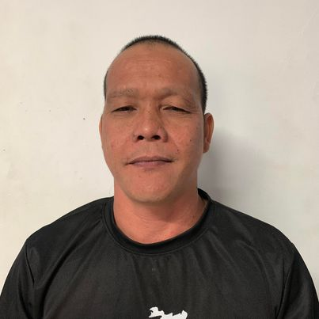

April 5, 2022

**CERTIFICATE OF DETENTION**

**TO WHOM IT MAY CONCERN**

**THIS IS TO CERTIFY** that one **JUN LANCETA MARCILLA**, male, 41 years old, born on **June 20, 1980**, married, resident **of Phase 1 Brgy. Milagrosa, Carmona, Cavite** was detained at this office since March 9, 2020 up to present and charged for the crime of **“Section 11 and 12 Art II of RA 9165”** with Criminal Case Nr. **CAR-2018-248/9,** before the Office of Provincial Prosecutor, Imus, Cavite.

This certification is being issued upon request of interested party for whatever legal purposes it may serve.

Prepared by :

Jun Marcilla, **PSSg Anderson A Videña**

Detainee Custodial Officer